PROJECT REPORT TEMPLATE

1 INTRODUCTION

* 1. Overview
  2. Purpose

2 PROBLEM DEFINITION & DESIGN THINKING

2.1 Empathy map

2.2 Ideation & Brainstorming map

3 RESULT

3.1 Data model

3.2 activity & screenshot

4 ADVANTAGES AND DISADVANTAGE

5 APPLICATION

6 CONCLUSION

7 FUTURES

8 PULISHING DASHBOARD AND REPORTS TO TABLEAU PUBLIC

**1 INTRODUCTION**

* 1. OVERVIEW

Agriculture is an evolutionary process that consists of a series of activities such as the production of food ,fibres, feed and raising of domesticated animals to fulfil the demand of the population. Agriculture is a key to development in the area of human civilization.

1.2 PURPOSE

Agriculture with its allied sectors is the largest source of livelihood in India . seventy percent of its rural households still depend primarily on Agriculture for their livelihood with eighty two percent of farmers being small and marginal. Agriculture is the foundation of Indian economy.

**2 PROBLEM DEFINITION & DESIGN THINKING**

2.1 Empathy map

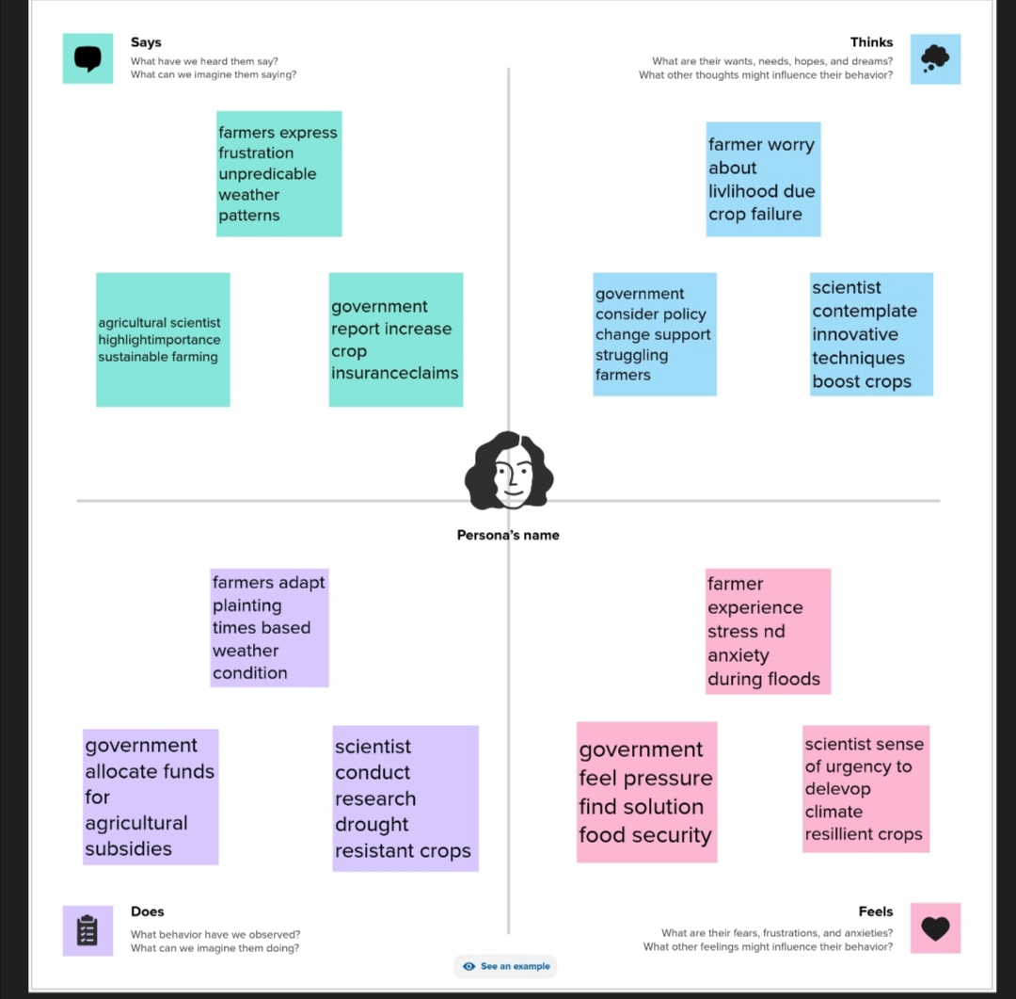

<https://github.com/asaluau0121bma0516/India-s-agricultural-crop-production-analysis-1997-2021-_NM2023TMID2670>

2.2 Ideation and brainstorming 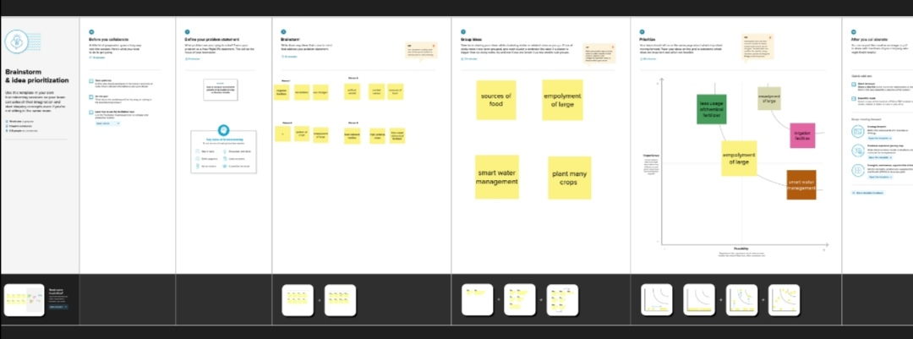

<https://github.com/asaluau0121bma0516/India-s-agricultural-crop-production-analysis-1997-2021-_NM2023TMID26706>

**3 RESULT**

3.1 Data model

1. specify the business problem .
2. Business requirement.
3. Literature survey.
4. Social or business impact.

3.2 Activity and screenshot

Milestone 1: Define problem / problem understanding

Activity : 1 specify the Business problem

The present challenges that plague Indian agriculture are limited knowledge and insufficient infrastructure, especially in the rural areas. problem related to lack of infrastructure, such as irrigation, market and transport, add huge cost to farmer’s operations. In addition, there are no proper delivery system and inadequate transport.

Activity : 2 Business Requirements

1. Agriculture business is based on many factors like the size of the land, fertility, type of soil, weather of the region, irrigation sources Irrigation facilities.
2. Farmers form business under one of the five basic business structure: sole proprietorship, limited liability company, partnership, corporation or cooperative.
3. At present ,AGRI business is defined as all business enterprises or sells to farmers/traders/consumers .the transaction may involve either an input or a produce or service and encompasses items such as : productive resources like feed, seed, fertilizer, equipment, energy , pesticides, machinery,…,

Activity : 3 Literature survey

The impact of environment and climate change could be observed thoroughly which plays important role for production and any other activity .along with the objective of storage, marketing facilities, recycling process, employment facilities and customer based strategy .the economic survey report has mentioned following drawbacks of the agricultural sector.

Activity : 4 social or business impact

The history of agriculture in the Indian dates back to the The Neolithic period. India ranks second worldwide in farm outputs . as per Indian economy survey , Agriculture employed more than 50% of the Indian workforce and contributed 20.2% To the country’s GDP.

Milestone: 2 Data collection and extraction

|  |  |
| --- | --- |
| OBJECT NAME | FIELD IN THE OBJECT |
| State | Text |
| District | Text |
| Crop | Text |
| Year | Number |
| Season | Text |
| Area | Number |
| Area unit | Text |
| Production | Number |
| Production unit | Text |
| Yield | Number |

Activity : 1 Downloading the dataset

Download the data the link given in official website

Activity : 2 Connect the data set in the tableau

* open a tableau
* Add the data set in the text option.
* continue the procedure.

Milestone : 3 Data preparation

Activity : 1 prepare the data for visualisations

Here the data set is available and the visualisation are showed in the activity

Milestone: 4 Data visualisations

Activity : 1 Number of unique visualisations

activity :1.1 State wise agriculture land

1. open tableau.
2. Drag area to rows and colour to filter.
3. Drag area to filter.

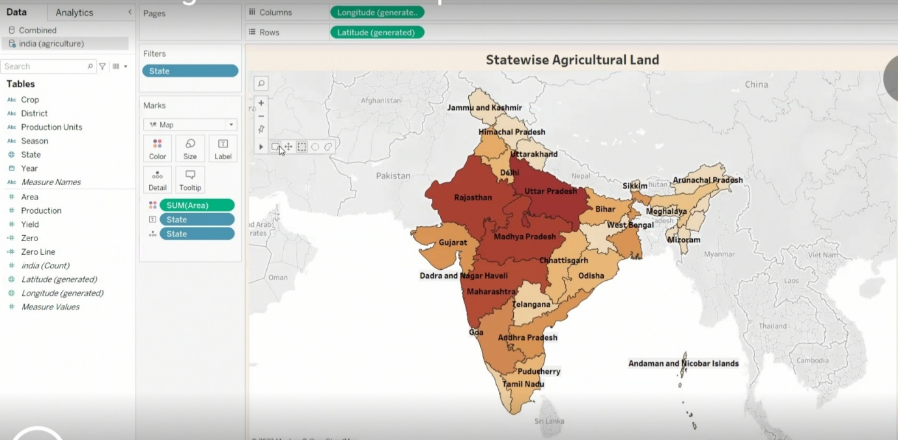

Activity : 1.2 Area vs production

1. Drag state to text .
2. Drag state to filter.
3. Drag area and production to columns .

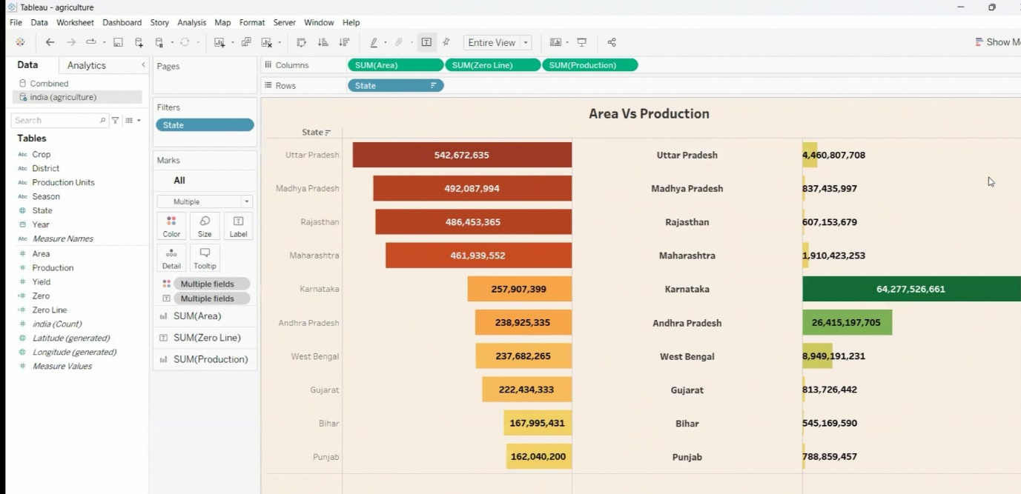

Activity :1.3 Season based cultivation

1. Drag year to columns
2. Drag year to rows
3. Drag season to colour

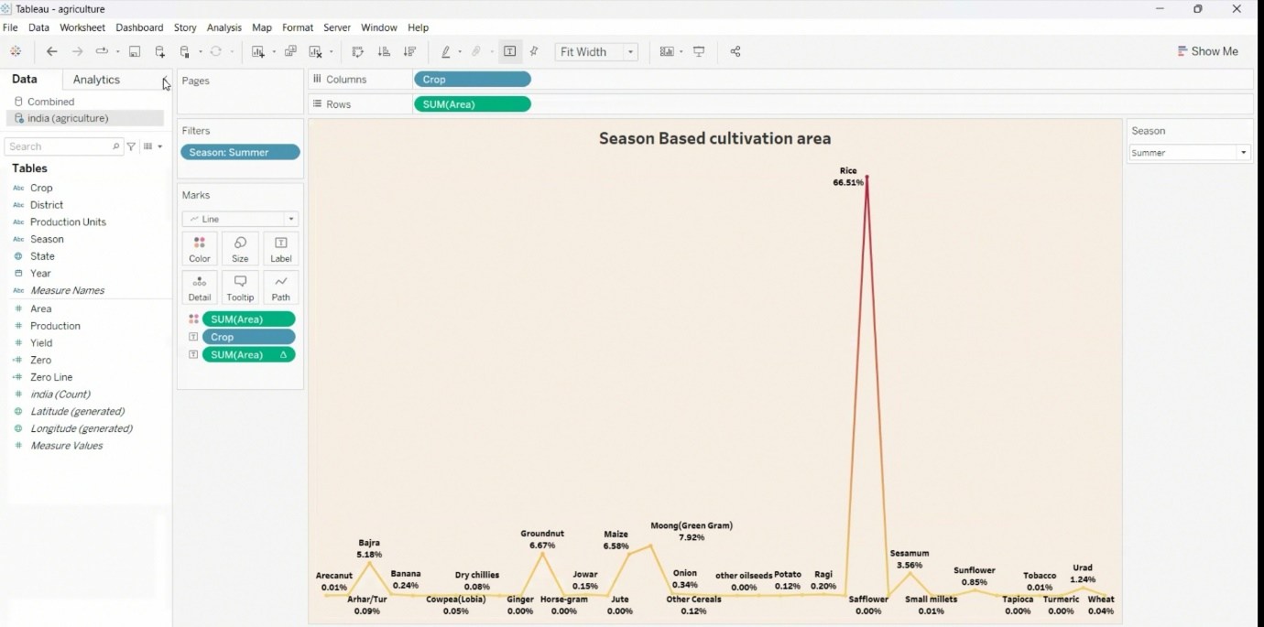

Activity :1.4 Yield by season

1. Drag crops to columns
2. Drag area to rows
3. Drag crop to filter

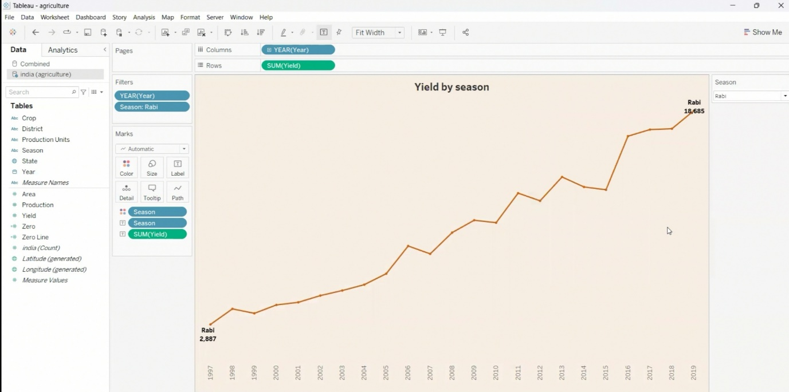

Activity :1.5 Crop plantation by area

1. Drag area to column
2. Drag production to row
3. Drag production to label

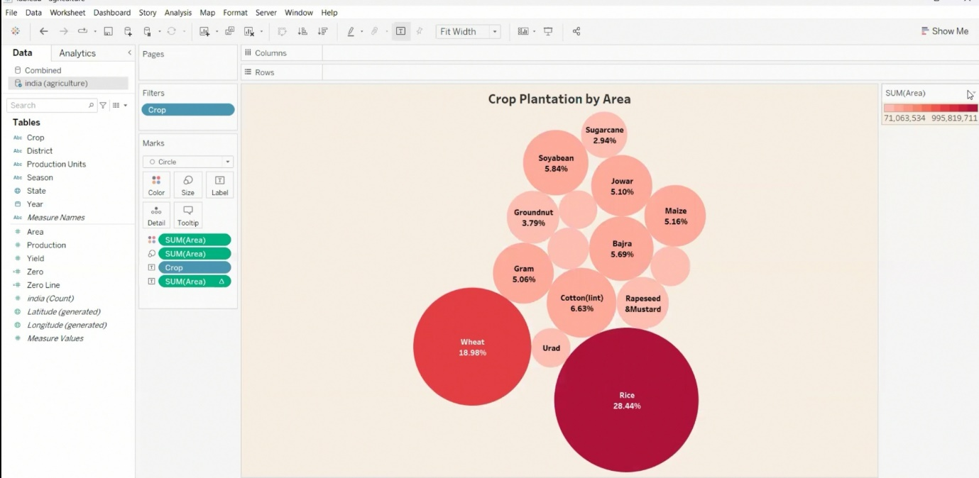

Activity :1.6 Crops

1. Drag crop to text
2. Drag colour to text
3. Drag crop to columns

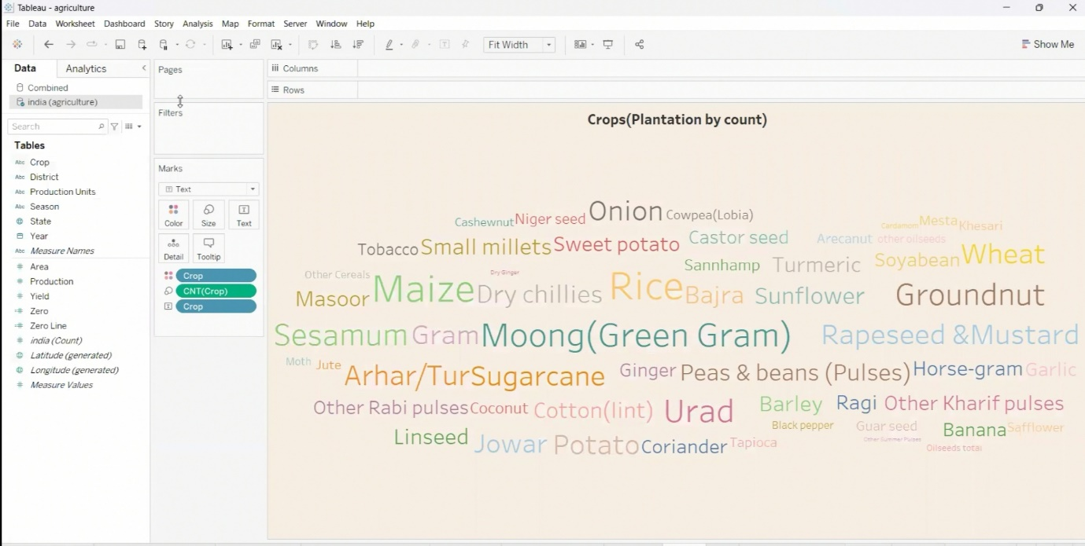

Activity :1.7 Season wise production

1. Drag crop to column
2. Drag area to rows

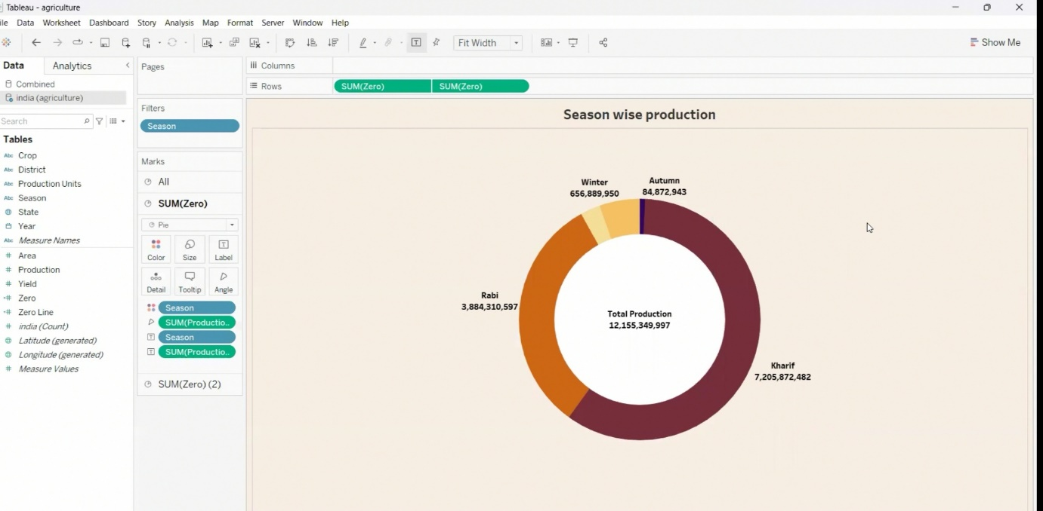

Milestone : 5

DASHBOARD:

1. Drag yield by season and major crop growth and season wise production to dashboard .

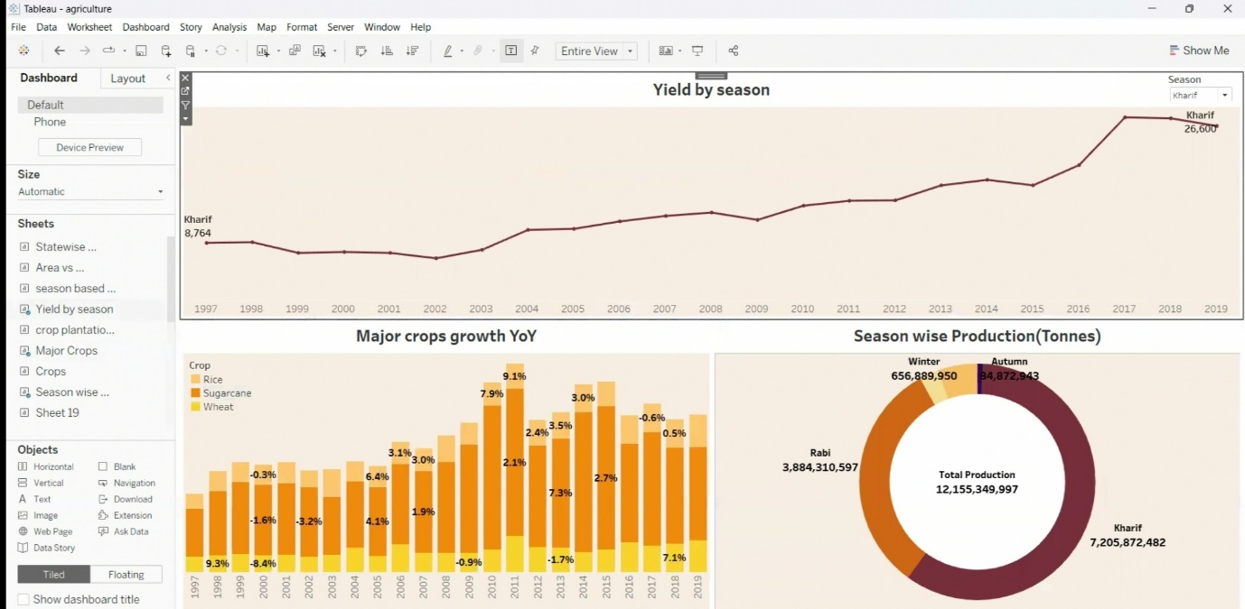

Milestone :6

STORY:

Drag all the graph to the story .

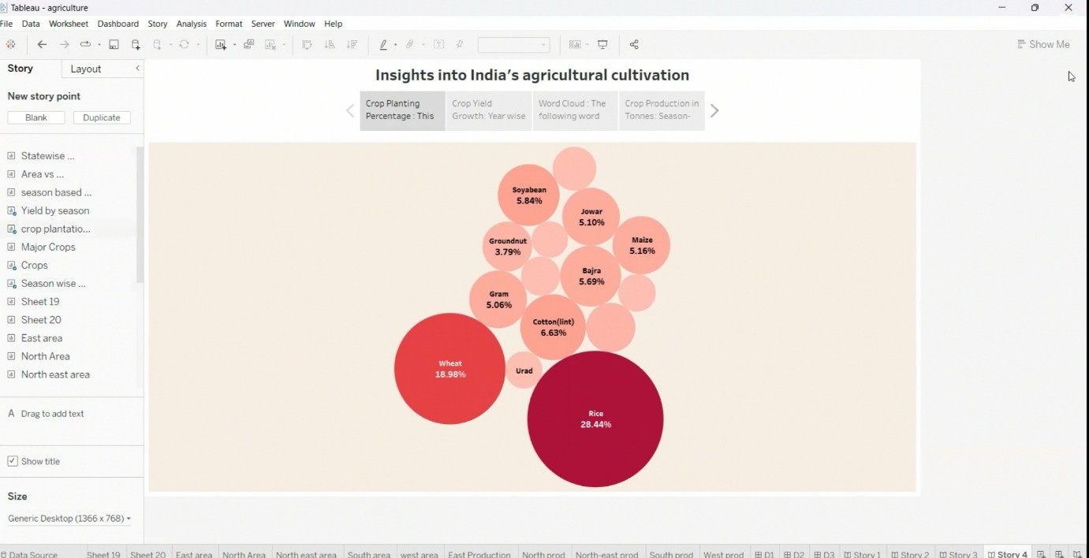

**4.Advantages and disadvantages**

ADVANTAGES:

1.Agriculture impacts society in many ways, including :supporting livelihood through food , habitat, and jobs ;providing raw materials for food and other products ;and building strong economies through trade

2.It provides employment opportunity to the rural agricultural as well as non-agricultural labourers.

3.Agriculture is a major contributor to the global economy.it provides employment to millions of people worldwide, especially in rural area. additionally, agriculture supports various industries, including food processing, transportation, and retail.

4.Improves the fertility of the soil-increment the cost and request of the items.

5.Decrease the effect on ecosystem-modern farming has modern storage methods that reduce wastage of food grains.

DISADVANTAGE:

1.Environmental degradation: Intensive agriculture can lead to soil erosion, deforestation, water pollution, loss of biodiversity .

2.Depletion of natural resources: agriculture can lead to the depletion of natural resources such as water and soil, and can lead to land degradation and desertification.

3.Modern farming methods have overused the natural resources base.

4.Increase the use of fertilizer has lead to loss of soil fertility

5.The use of groundwater for tube well irrigation has led to water depletion.

6. Biggest drawback would be adapting to the significant shift in the environment .

1. **APPLICATION**

1.Application of AI in agriculture provides farmers with real-time crop insights, helping them to identify which areas need irrigation, fertilization, or pesticides treatment.

2.Agri app is a farmers app that helps farmers stay updated on the best farming and agricultural practices.

3.AI can help detect field boundaries and bodies of water to enable sustainable farming practices, improve crop yields, and support india’s 1.4 billion and the rest of the world.

4.kisan suvidha is an omnious mobile app developed to help farmers by providing relevant information to them quickly.

5.GPS and GIS are both used in precision agriculture for many purposes including farm planning, field mapping , soil sampling, crop scouting, and yield major crops.

**6 CONCLUSION**

1.The above presentation clearly specifies the significance of agriculture.

2.Agriculture also describes that agriculture is primary and also has commercial value.

3.Though the future of India is industrialisation, the contribution of agriculture would always prove to be vital for making India powerful & stable economy in the future.

4.Though the industries are considered as modern temples of economy, without agriculture no economy or industry can survive for long.

**7 FUTURE SCOPE**

1.There is a Tremendous scope for agriculture because food and food products are indispensable for the survival of humanity.

2.A growing industry with diverse career opportunities.

3.Due to globalisation, increase in household incomes and health consciousness the demand for fruits and vegetables, diary products, fish and meat is going to increase in future.

8 PUBLISHING DASHBOARD AND REPORTS TO TABLEAU PUBLIC

TEAM LEAD:

DASHBOARD LINK : <https://public.tableau.com/app/profile/pavithra.veerappan/viz/Insightintoindiasagriculturalcultivation/Dashboard3?publish=yes>

STORY LINK : <https://public.tableau.com/app/profile/pavithra.veerappan/viz/Insightintoindiasagriculturalcultivation/Story1?publish=yes>

MEMBER ONE:

DASHBOARD LINK: <https://public.tableau.com/app/profile/prasanna.nayagi.p/viz/IndiasAgriculturecropproductionanalysis_16967426449340/Dashboard1?publish=yes>

STORY LINK: <https://public.tableau.com/app/profile/prasanna.nayagi.p/viz/IndiasAgriculturecropproductionanalysis_16967426449340/Story1?publish=yes>

MEMBER TWO:

DASHBOARD LINK: <https://public.tableau.com/app/profile/pragathi.v8683/viz/IndiasAgriculturecropproductionanalysis/Dashboard1?publish=yes>

STORY LINK: <https://public.tableau.com/app/profile/pragathi.v8683/viz/IndiasAgriculturecropproductionanalysis/Story1?publish=yes>

MEMBER THREE:

DASHBOARD LINK:

<https://public.tableau.com/app/profile/pooja.chandran/viz/poojaagreedashboard/Dashboard1?publish=yes>

STORY LINK: <https://public.tableau.com/app/profile/pooja.chandran/viz/poojaproject1___/Story1?publish=yes>

**8 DEMO VIDEO**

DEMO VIDEO LINK:

<https://drive.google.com/file/d/1eBYaRO5m63kBvpT3FJ73bFSUnqBWawbT/view?usp=drivesdk>